Microplastics in Labeo rohita
Microplastics are plastic particles found everywhere that are under 5mm in diameter that find their way into many food chains. Recent studies in Labeo rohita and other species have shown that polystyrene microplastics (PS-MPs) in their food can build up in tissues, change normal functions, and damage organs, this could prove detrimental to many aquatic ecosystems around the world. My project focuses on how PS-MPs affect the blood health of Labeo rohita. My hypothesis is that Increasing concentrations of dietary polystyrene microplastics in Labeo rohita feed will lead to a measurable decline in hematological health, specifically resulting in decreased red blood cell count and hemoglobin concentration.
Other studies done before show that microplastics can harm marine life from small fish to whole ecosystems. Zeng et al. extended this idea to marine invertebrates by showing that microplastics that have been in the seawater for long periods of time made from common plastic types such as polystyrene (PS-MPs) and PVC caused more death, stress, and damage to tissue in curtain clams in the Philippines during long term exposure. This could tell us that microplastics left to age in seawater might be more toxic as they age. In another experiment with the cold water coral Lophelia pertusa showed that both macro- and microplastics reduced skeletal growth and changed feeding behavior. This tells us that microplastic contamination affects the backbone of the ecosystem, not just the individual animals.
The data for this project come from a 90 day feeding trial in which Labeo rohita fish were fed six diets containing 0% (Control), 0.5%, 1%, 1.5%, 2%, or 2.5% (PS-MPs) mixed into a canola based feed. For each diet there were three identical tanks with 15 fish per tank My analysis uses the hematology table and the feed composition tables from the study, which provide red blood cell count, white blood cell count, platelet count, hemoglobin concentration, mean hemoglobin concentration, mean hemoglobin, mean volume, and cell volume for each PS-MPs level, along with the percentage of PS-MPs, gross energy, crude fat, and crude protein in the corresponding feed. These blood variables were measured at the end of the 90 day experiment using fish hematology methods described in the article, and the feed were analyzed for any changes in the composition. Because each data point represents the average of the tanks at a given PS-MPs concentration, the dataset captures very clear dose response trends to the concentration of PS-MPs introduced in the diet but has only six different treatment levels, which is important to keep in mind when looking at the upcoming figures.
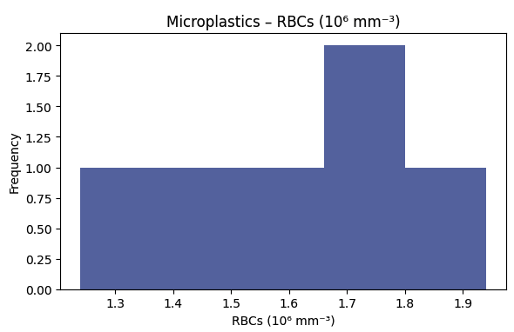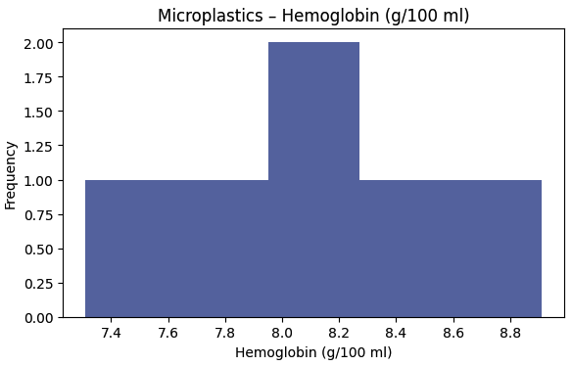
Figure 1. How Microplastic concentration in feel affect the Red blood cell & Hemoglobin count in Labeo rohita.
For the correlation analysis, I compared the PS-MPs concentration in the feed to three important blood parts: red blood cell (RBCs) count, hemoglobin (Hb) concentration, and white blood cell (WBCs) count. Using both the Pearson and Spearman correlation, I found very strong negative relationships between PS-MPs and RBCs and between PS-MPs and Hb, this tells us that as the concentration of PS-MPs in the diet increase, the RBCs and Hbs decrease. However, PS-MPs showed a very strong positive correlation with WBCs. This illustrates that as the concentration of PS-MPs increased in the diets of the fishes, the WBCs also increased, this is also consistent with an immune system reacting to invaders. The Spearman coefficients were close to ±1, which shows that the trend was continuous positively or negatively correlated with no opposite movements. Together, these correlations support my hypothesis that increasing dietary PS-MPs induces a decline in blood health by lowering RBCs and Hbs, while also demonstrating a strong increase in WBCs with dose.
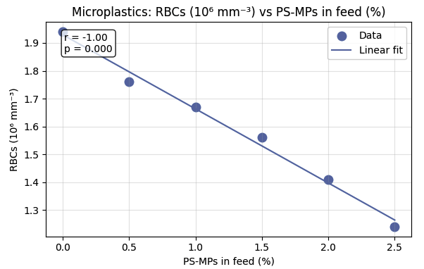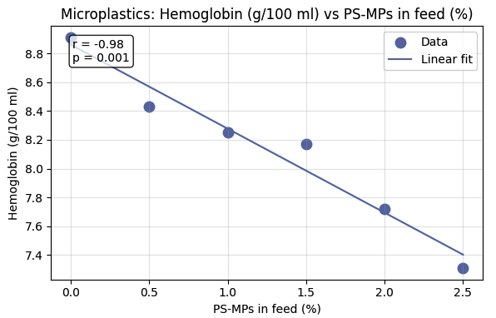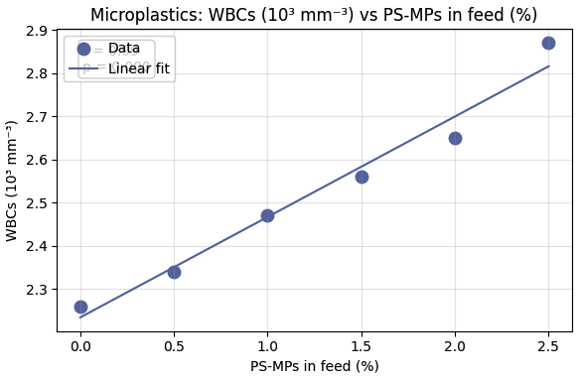
Figure 2. This figure explains the negative linear relation the Red blood cells & Hemoglobin has with the introduction of more microplastics as well as the linear relationship between the White blood cells and the introduction of more microplastics.
Principal component analysis (PCA) is a method that takes a lot of variables that are related to one another and turns them into a few new ones, called principal components, that show the main patterns in the data. In this project I used PCA on the blood variables (RBCs, Hb, & WBCs) and then plotted the first two components, PC1 and PC2, after I color coded the points by PS MPs dose in the feed (0%, 0.5%, 1%, 1.5%, 2% and 2.5%). I chose dose as the grouping variable because my hypothesis is whether changes in blood line up with increasing microplastic exposure. The PCA plot shows that PC1 explains the variation, and the points spread along its axis roughly following the PS-MPs concentration. The control fish with 0% PS-MPs are at one extreme of PC1, while fish fed the highest PS-MPs doses are at the opposite end, with the other concentrations in between. PC2 explains less than 1% of the variance, this shows that most differences in blood profiles can be seen by a variable that is related to the PS-MPs concentration in the diet.
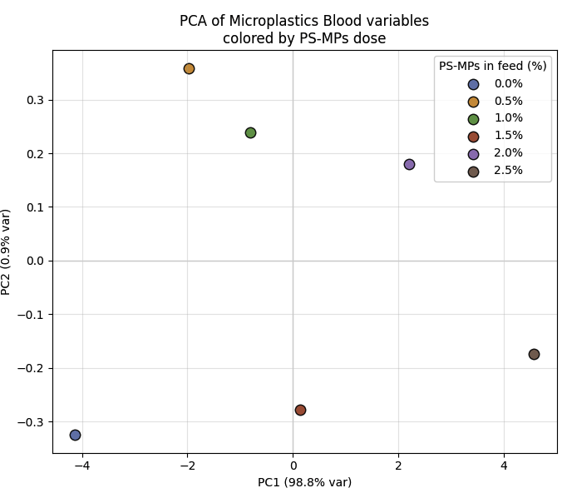
Figure 3. This is the PCA where the PS-MPs level is closely correlated with the differences in the blood profile of the fishes.
From this analysis I learned that dietary PS-MPs have a clear, dose dependent effect on the blood health of Labeo rohita. As PS-MPs in the feed increased, both red blood cell count and hemoglobin concentration declined sharply, while white blood cell count increased. These patterns were shown also in very strong correlation coefficients and basically perfect linear regressions. The PCA results also showed that almost all of the variation in the hematology data can be shown through a single axis that is PS-MPs dose. With both findings strongly supporting my original hypothesis that higher concentrations of dietary PS-MPs would reduce RBCs and Hb, we can conclude that PS-MPs does have a declining effect of RBCs and Hbs.
The strength of the conclusion is limited by the small number of doses of PS-MPs. The results could also tell us that microplastics in aquaculture feeds can alter fish in ways that are detrimental. This has serious implications for the welfare of fish, food safety for humans and other animals, and the design of cleaner production systems in environmental engineering that will not leach microplastics into our waterways.

Bibliography
Rashid, E., Hussain, S.M., Ali, S. et al. Polystyrene microplastics exposure in freshwater fish, Labeo rohita: evaluation of physiology and histopathology. Sci Rep 15, 12888 (2025). https://doi.org/10.1038/s41598-025-95811-3
Zeng, L., Yang, H., Tong, T. et al. Study on the toxic effect of seawater-aged microplastics on Philippine curtain clams. Sci Rep 15, 18078 (2025). https://doi.org/10.1038/s41598-025-02823-0
Chapron, L., Peru, E., Engler, A. et al. Macro- and microplastics affect cold-water corals growth, feeding and behaviour. Sci Rep 8, 15299 (2018). https://doi.org/10.1038/s41598-018-33683-6

Supplementary Figures

